# CSC 150: Computer Science I

# Assignment 5

Pointers and Modular Programming

**Learning Objectives**

* To learn about pointers and indirect addressing
* To see how to access external data files in a program and to be able to read from input files and write to output files using file pointers
* To learn how to return function results through a function’s arguments
* To understand the differences between call-by-value and call-by-reference
* To understand the distinction between input, inout, and output parameters and when to use each kind
* To learn how to modularize a program system and pass information between system modules (functions)

Write a program to allow a machine to dispense change (quarters, dimes, nickels, pennies). The user enters the amount, in bills only, to be deposited into the machine. The machine reads a text file (database) that contains the current change in the machine.

If there is adequate change available, display a message to the user to insert the bill. Overwrite the text file lowering the change available by the change requested. If there is not sufficient change available, display a message to the user requesting a lesser amount and try again.

Program requirements:

* Beginning .c source code file used and authorship, date, etc. well documented
* External text file named *inventory.txt*
* Comments describing the statement actions
* Display the amount inserted in dollar ($) format
* Accepts only 1, 5, 10, 20 or 50 dollar ($) bills
* Displays a message to insert an acceptable bill
* Displays a message to insert a smaller bill if the inventory is below the entered bill amount
* Display, at the end of the program:
  + Beginning inventory in dollar format
  + Ending inventory in dollar format
* Convert possible negative bill entries to positive integers

Compile, run and test your program.

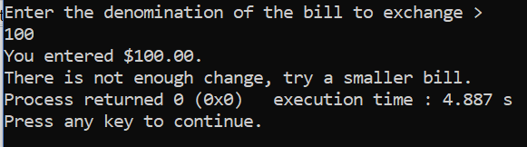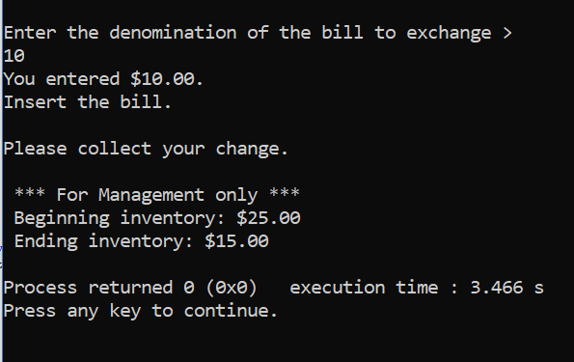Submit the working .c file to the Assignment 5 Dropbox.